**5-2 Milestone Four: Enhancement Three: Databases**

Christopher King

Southern New Hampshire University

CS-499 Computer Science Capstone 2024

Professor Conlan

December 1, 2024

**5-2 Milestone Four: Enhancement Three: Databases**

* **Briefly describe the artifact. What is it? When was it created?**
  + The Rescue Animal app started as a Java-based project focused on managing rescue animals, including dogs and monkeys. It featured a Driver.java program to interact with the data via basic console inputs. The artifact has been transformed into a full-stack application using Node.js, Express, MongoDB, and Angular, enhancing its scalability and functionality. The original project was created during the IT-145 course, and the enhanced version was developed as part of the CS-499 capstone project.
* **Justify the inclusion of the artifact in your ePortfolio. Why did you select this item? What specific components of the artifact showcase your skills and abilities in software development? How was the artifact improved?**
  + The Rescue Animal app showcases my ability to design, develop, and enhance a complete software solution. It highlights skills in transitioning from standalone java application to a full-stack project, and implementing modular design and database integration.
  + Original Code Example: demonstrates fundamental programing skills including object instantiation and array list management

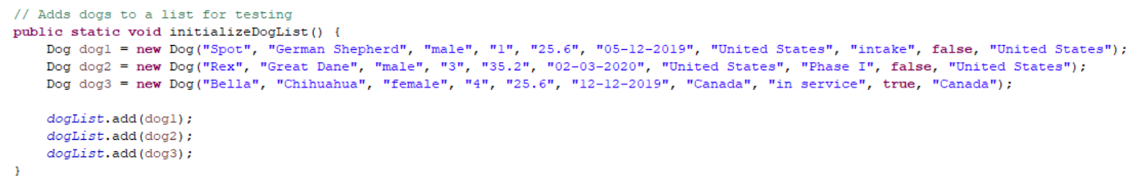

* + Enhanced Code Example: This schema illustrates my ability to define and implement database models using MongoDB

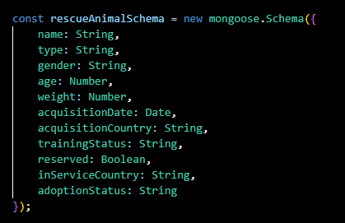

* + This artifact was enhanced by replacing Java data structures with NoSQL database for better scalability, adding RESTful APIs for seamless data integration, and incorporating modern design principles in the front-end and back-end.
* **Did you meet the course outcomes you planned to meet with this enhancement in Module One? Do you have any updates to your outcome-coverage plans?**
  + Yes, the enhancements aligned with several course outcomes such as transitioning to a modular full-stack architecture (Designing and evaluating computing solutions), and the integration of MongoDB and RESTful APIs demonstrates the use of industry-specific tools (Using innovative techniques). For this milestone I updated the home screen to include “Login” and “Register” buttons and also made it so that the “Add New Animal” and “Edit” buttons are not accessible unless the user is logged in. I also enhanced the Add New Animal form to contain drop downs for type, gender, training status, and species in order to restrict the possible entries. The form is also reactive and additional fields are provided when monkey is selected.
* **Reflect on the process of enhancing and modifying the artifact. What did you learn as you were creating it and improving it? What challenges did you face?**
  + *MOD 3 Entry* As I was enhancing and modifying the artifact, I realized that organization and a roadmap of how the artifact would be enhanced is essential. In the beginning, I was updating all sections at once and not focusing on a specific aspect of the application. This lead to some confusion on my part and I had to go back and re-organize the components in a more efficient way. I also did not comment as I was working, so I had to go back and input all/most of my comments. I plan to complete this as I move forward so there is less confusion and so I do not have to go back and complete it.
  + *MOD 4 Entry* For this mod I made sure I had a plan as to what I wanted to enhance and focused on each aspect individually. I started with the login and register buttons, once I had them working I proceeded to work on restricting items if the user was not logged in. Then I worked on enhancing the intake form to ensure certain items had to be selected to ensure consistency between entries. I had some setbacks when trying to get the login and register forms to center on the page, in the end I did further research on how I could implement styles and finally figured it out.
  + *MOD 5 Entry* For this mod I worked on fine tuning the usability and some security aspects of the application. I updated the home screen to include the company logo and name, along with adding a mission statement to make the site look more professional. I updated the intake form to include phases when the status is set to in-training, this was done to align with the original specification document that was provided for the original project. I made it so in order to register on the site, a registration code needs to be entered, currently this code is hardcoded but will be updated during the next week. This will ensure only those that are granted access to add or edit will have the ability to register on the site. I updated the animal listing to include multiple buttons for the most used queries to make the sorting more user friendly. While working on my project this week, I ran into a few issues getting items to line up properly. In order to correct this, I started looking further into CSS and HTML code to figure out what needed to be done to make it work. This involved diving deeper into the subject then I did in my classes up to this point.

**Screenshots on Enhancements made this Module:**

**Original Home Screen**

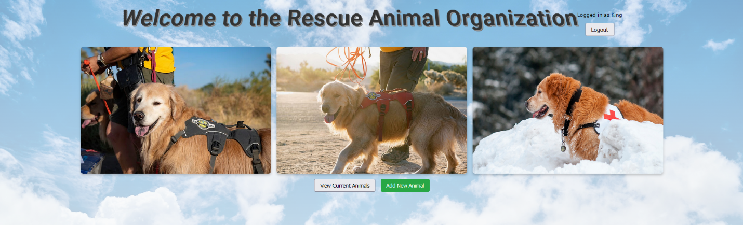

**Enhanced Home Screen (Logo and mission statement added)**

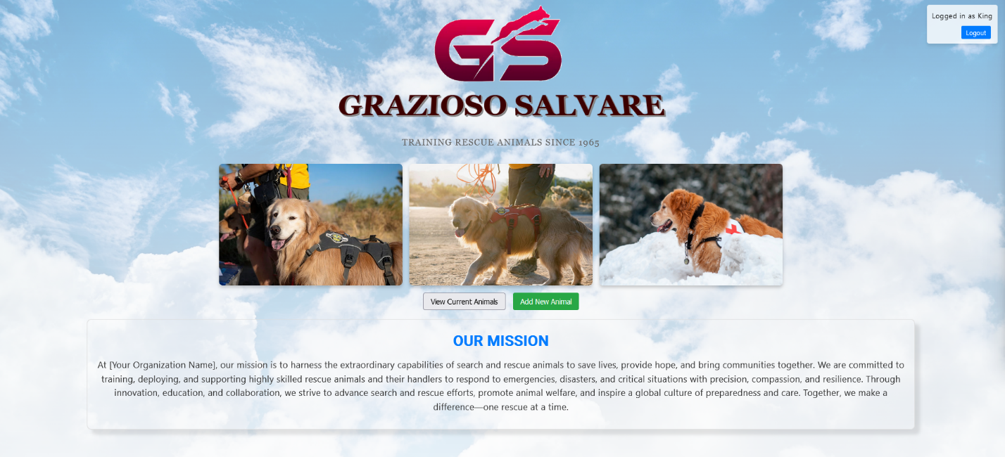

**Original Animal List**

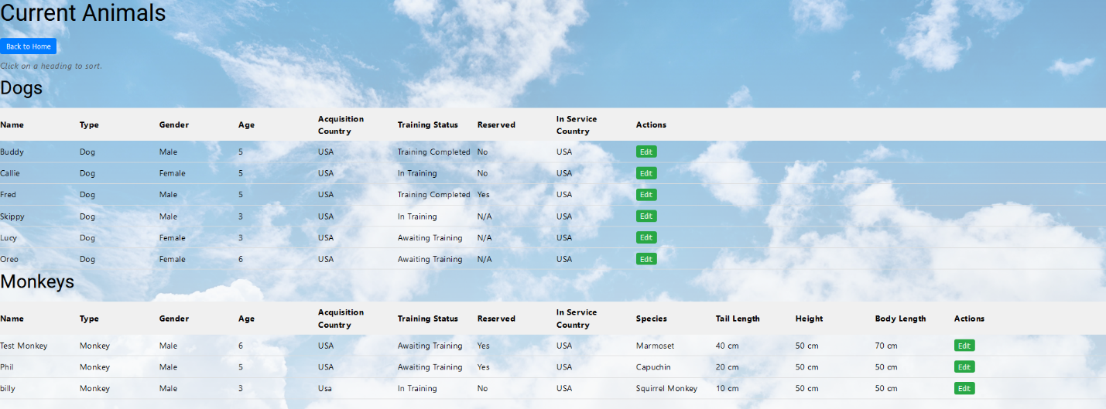

**Enhanced Animal List (Not Logged In)**

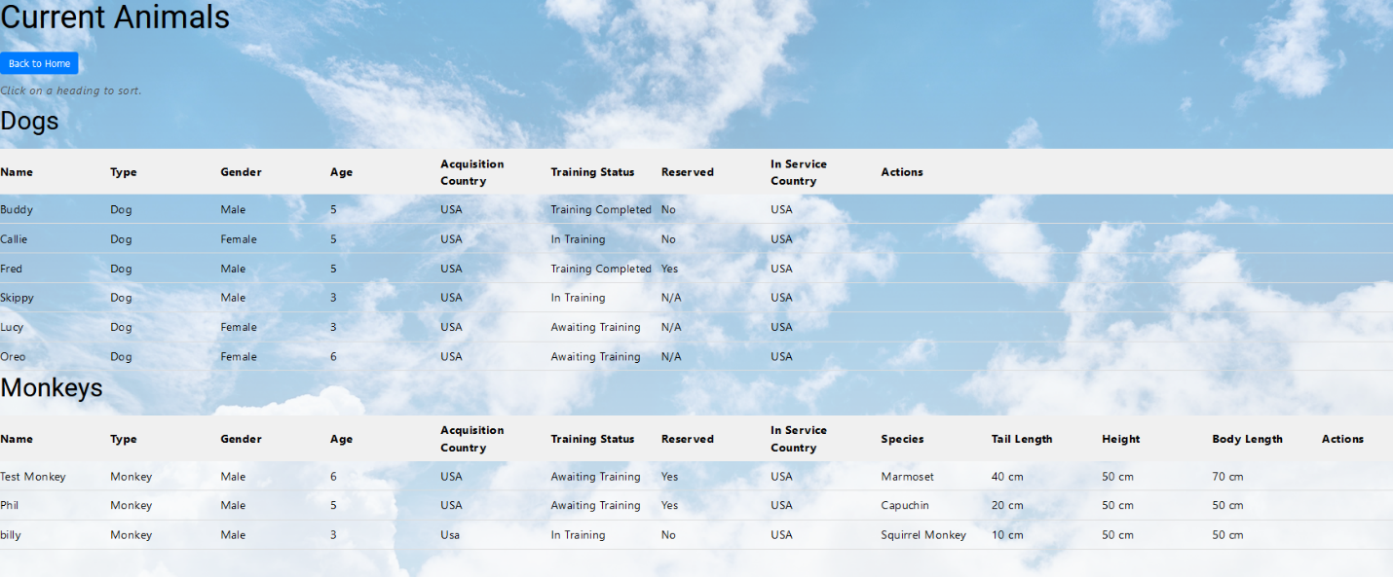

**Enhanced Animal List (Added/Cleaned up headings and added most used query buttons)**

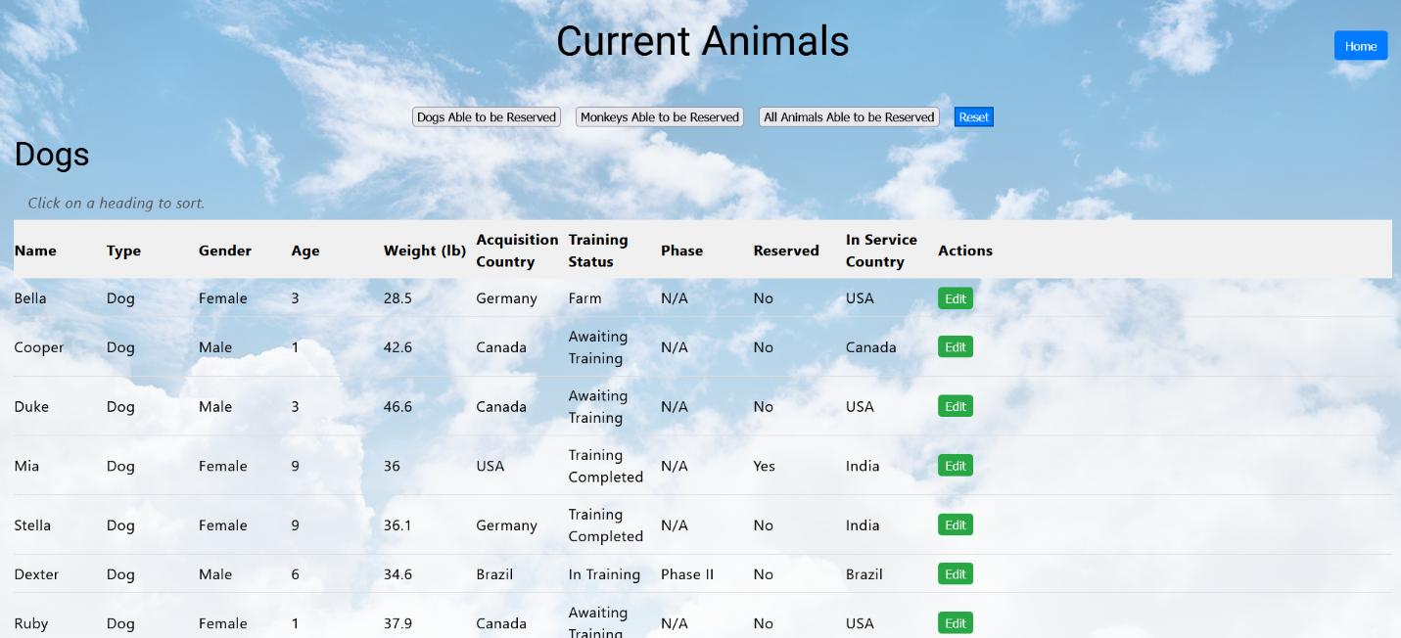

**Original Intake Form**

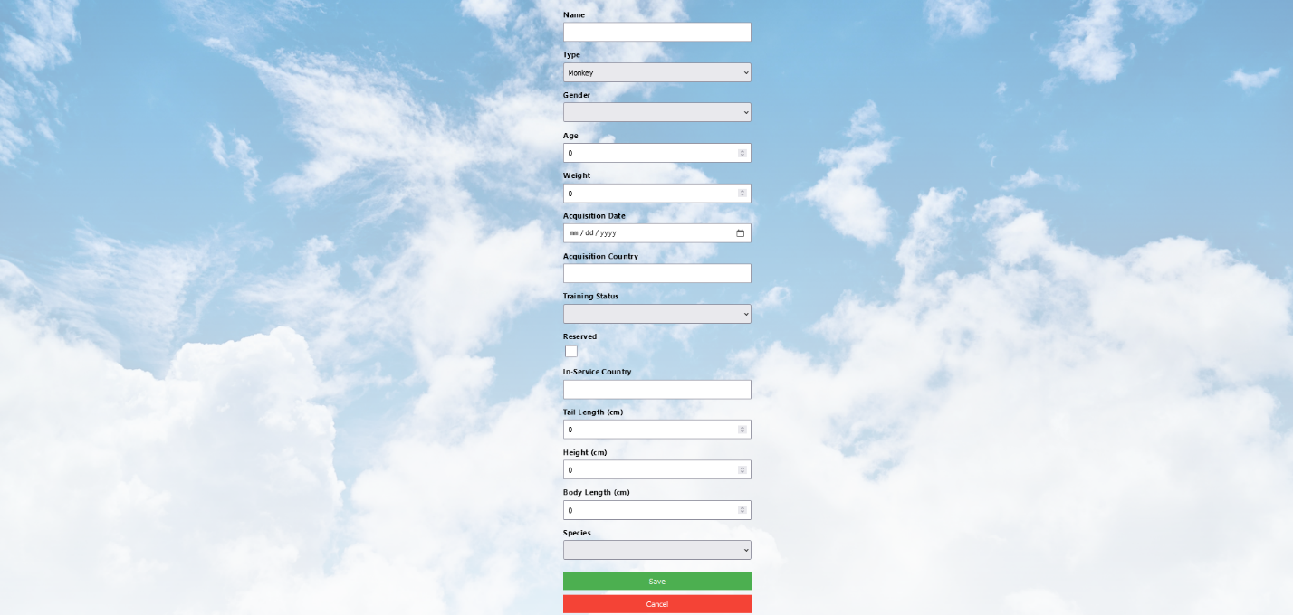

**Enhanced Intake Form (Added phases if in-training status is selected)**

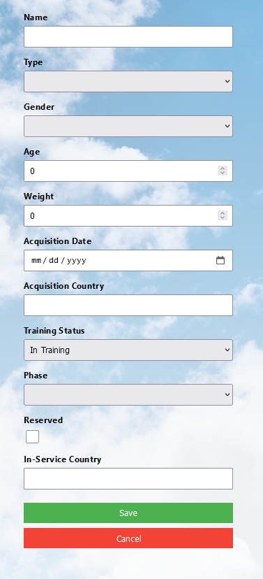

**Original Registration Screen**



**Enhanced Register Form (Now includes a registration code that will be required to register)**

